**Q 1: Build a Docker image using docker file**

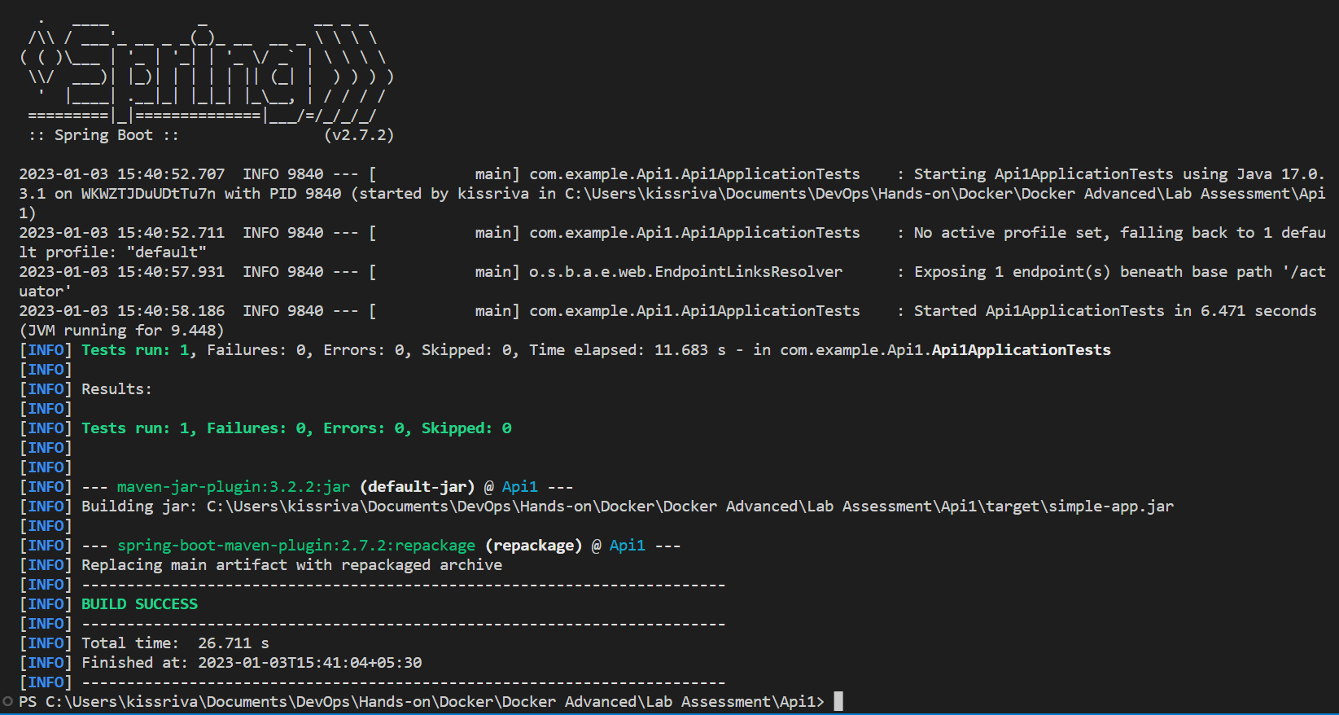

**Package the code using mvn clean package**

FROM openjdk:17

WORKDIR /app

ADD Api1/target/simple-app.jar simple-app.jar

EXPOSE 5000

ENTRYPOINT [ "java", "-jar", "simple-app.jar"]

**Content of Dockerfile**

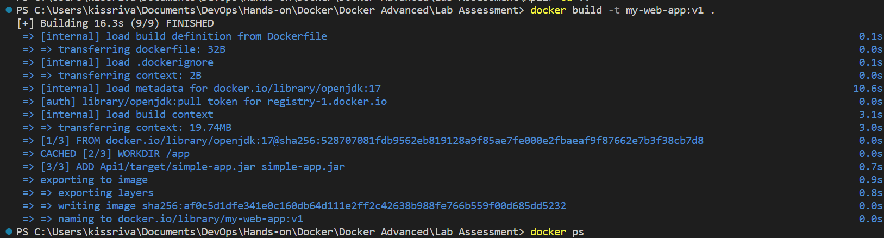

**Build the image**



**Image created with tag v1**

**Q 2: Build an OCI image from source code with Cloud-Native Build Pack**

<plugin>

                <groupId>org.springframework.boot</groupId>

                <artifactId>spring-boot-maven-plugin</artifactId>

                <configuration>

                    <imageName>my-web-app:v2</imageName>

                </configuration>

            </plugin>

**Include the following configuration in pom.xml**

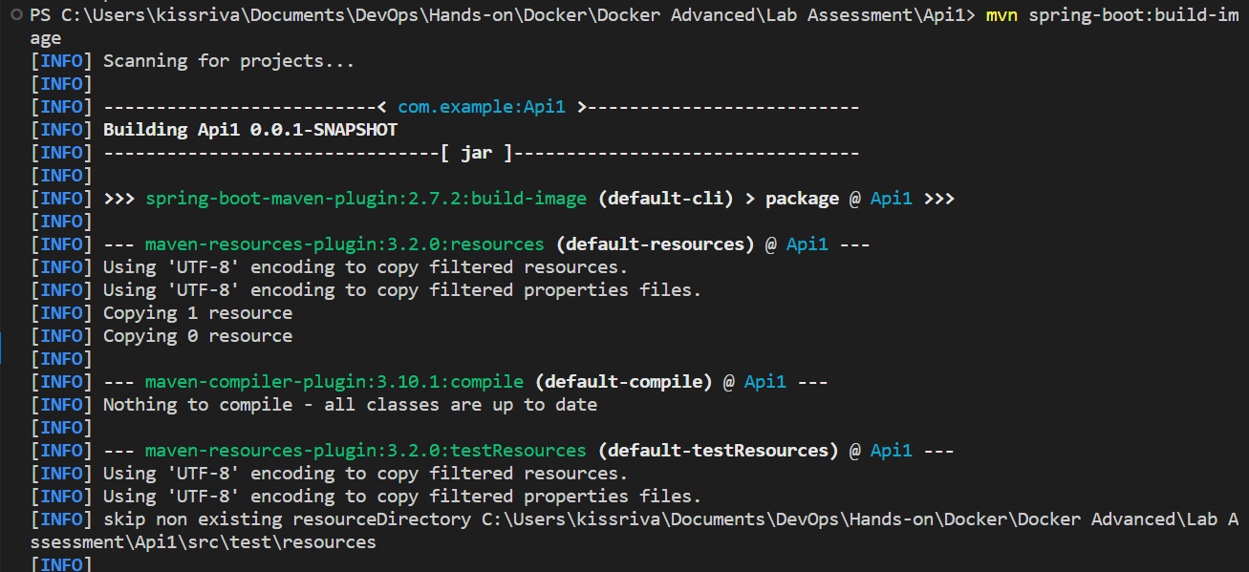

**Building the image using Build Packs (it is included in maven package)**



**Image created with tag v2**

**Q 3: Optimized the image at runtime by splitting part of JAR into different layers using layer tools.**

            <plugin>

                <groupId>org.springframework.boot</groupId>

                <artifactId>spring-boot-maven-plugin</artifactId>

                <configuration>

                    <layers>

                        <enabled>true</enabled>

                    </layers>

                </configuration>

            </plugin>

**Add the following configuration in pom.xml**

FROM adoptopenjdk:11-jre-hotspot as builder

WORKDIR application

COPY Api1/target/simple-app.jar simple-app.jar

RUN java -Djarmode=layertools -jar simple-app.jar extract

FROM adoptopenjdk:11-jre-hotspot

WORKDIR application

COPY --from=builder application/dependencies/ ./

COPY --from=builder application/spring-boot-loader ./

COPY --from=builder application/snapshot-dependencies/ ./

COPY --from=builder application/application/ ./

ENTRYPOINT ["java", "org.springframework.boot.loader.JarLauncher"]

**Multistage Dockerfile which extracts and includes different layers of jar file**

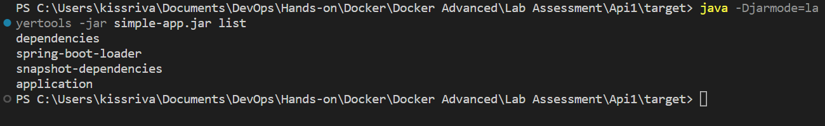

**Different layers in the jar file**

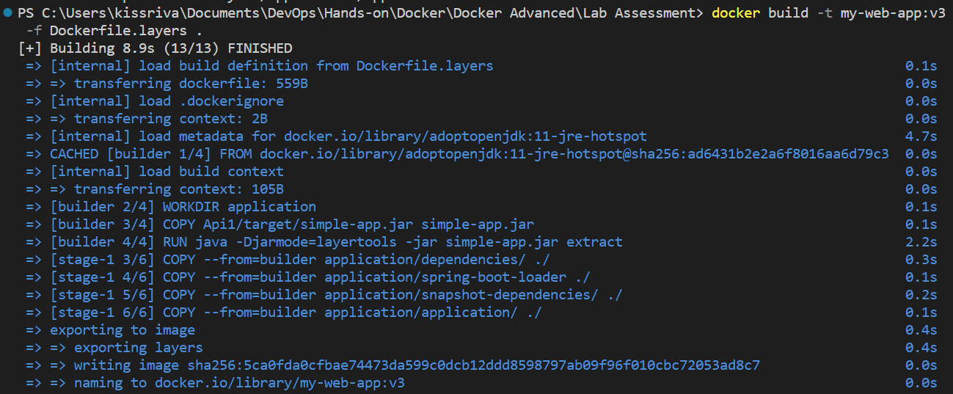

**Building the image**



**Image created with tag v3**